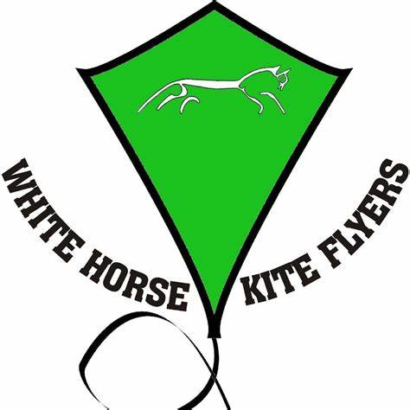

WHKF Fun Fly Menu 2024.

Weekend Breakfast – £6.00

The breakfast Bap, filled with bacon, sausage & fried egg, served with your choice of either tomato ketchup or HP brown sauce.

Weekend Lunch – £6.00

Jacket Potatoes and Fillings.

Saturday Dinner –£12.00

Pasta and Bolognese.

Dessert –

Fruit crumble.

Vegetarian options will be available.

Please note ALL meals MUST be pre-ordered to save on waste.

Special offer: - ALL five meals for £30.